
August 24, 2023

NNAMDI JOSEPH EGERUE
3, Ehoro Crescent Elelenwon, Rivers State
08162561172
08162561172
22181313036
Dear Sir,

OFFER OF BANKING FACILITY
Optimus Bank Ltd (“the Bank”) is pleased to offer the following credit facility(ies) to NNAMDI JOSEPH EGERUE (“the Borrower”) under the following terms and conditions
Borrower : NNAMDI JOSEPH EGERUE

Lender/ Bank : Optimus Bank Limited
Facility Amount : N15,000,000 (Fifteen Million Naira Only)

Facility Type : Optimus Premium Avanzar

Tenor : 52 weeks
Purpose : To finance personal needs of the Borrower

Repayment Terms* : Equal weekly repayment of Principal & interests

Repayment Schedule : The repayment Schedule shall be provided upon
acceptance of the offer.

Repayment Source : Commissions, Bonuses, Profits & all inflows from Gaming Business
Annual Percentage Rate: 13.61%

Interest : 22% subject to review in line with prevailing money market conditions. However, notifications (written, electronic, or other modes of communication) would be given ten (10) working days before any



rate amendments are made.
Management Fee** : 1% of the Loan Facility to be recognized on Bullet Basis. Insurance Premium : 1% Flat (One Hundred and fifty Thousand Naira Only) Preferred Insurance Company: Old Mutual (The Assurer)
Collateral/ Security : Domiciliation of Borrower’s commissions, bonuses,
profits and benefits from KC Gaming Networks Ltd (Bet9ja)

Conditions Precedent to drawdown:
- Borrower’s request letter for the facility
- Duly executed offer letter by the Borrower
- Executed facility agreement between the Lender and the Borrower
- Confirmation from KC Gaming Networks Ltd (Bet9ja) to irrevocably domicile the Borrower’s commissions, bonuses, profits and benefits with the Bank throughout the tenure of the facility
- All documents or procedure required as a prerequisite to give effect to, or to take a charge on the security, and all conditions on this offer.

OTHER CONDITIONS
- The Borrower acknowledges that by signing this offer letter and by drawing on the loan, it covenants to repay the loan as and when due and hereby irrevocably undertakes to repay the principal and interest in 52 equal weekly instalments of ₦ 321,962.16K.
- The Borrower hereby authorizes the Bank to debit his/her current account 1000036233 for the weekly Loan repayment obligations comprising principal and interest and any default fees where applicable and unconditionally agrees that the interest charged on the Loan shall be at the Bank’s prime lending rate from time to time.
- The borrower pledges their right to own and operate a Bet9ja wallet to the Bank as additional comfort for the loan. And that the proceeds arising from the onward sales/takeover of the borrower’s outlet/Bet9ja location must first be applied to settle any indebtedness to the Bank.


- A late repayment fee of 1% flat per month (12% p.a.) over the approved lending rate shall be applied on the outstanding unpaid obligation without recourse to the Borrower provided that the Borrower shall be given a grace period of seven
(7) days from the date of default to repay the loan without any forbearance on the interest and penal fees accrued/accruing.
- In accepting this offer, the Borrower hereby confirms that the interest rates and charges stated herein were negotiated and mutually agreed with the Bank. Execution of this offer letter therefore conveys the Borrower’s consent to the application of these interest rates and charges at the Bank’s prime lending rate from time to time.
- The Borrower agrees that the disbursement of the Facility is at the sole discretion of the Bank and that the Bank is not obliged to disburse the Facility if the Bank is unable to source for such funds at a rate it considers commercially viable or if the currency of the Facility is not available. The Borrower also acknowledged that all out-of-pocket expenses and fees incurred by the Bank in processing the facility, enforcement of security and recovery of the facility in the event of default will be for the account of the Borrower.
- The Borrower authorizes Optimus Bank Limited to obtain and retain on the Credit Risk Management System of the Central Bank of Nigeria, all information relating to the Borrower’s Bank Verification Numbers and the status of indebtedness.

- The Bank may use any information relating to the Borrower to evaluate the credit application. The Borrower hereby waives any right of confidentiality whether arising under common law or statute or in any other manner whatsoever and irrevocably agree that it shall not argue to the contrary before any court of law, tribunal, administrative authority, or any other body acting in any judicial or quasi-judicial capacity.
- The Borrower hereby acknowledges and gives consent that the Bank may at its sole discretion as it shall consider appropriate, give to and receive from credit bureaus and reference agencies whether based locally or abroad, other financial institutions, regulatory and law enforcement agencies and relevant third parties, including guarantors for this loan facility, information about the Borrower, including information on the Borrower's directors and other personnel, transactions and conduct on the Borrower's account together with details of any non-payment or delayed payments for the purpose of assisting them and/or the Bank in making lending or rating decisions about the Borrower and/or making recovery efforts.
- The Borrower agrees to continue to carry on and maintain its business in conformity with all Health, Safety and Environmental Laws applicable in Nigeria,


whether required by the Bank or not, and supply evidence to verify its fulfilment of this obligation to the Bank.
- The Borrower also acknowledges that non-compliance with any Health, Safety and Environmental laws shall be an event of default, and the Bank shall at its discretion take steps to compel the Borrower to comply with all Health, Safety and Environmental obligations, at a cost to be borne by the Borrower.
- All legal fees, stamp duties and other costs associated with the documentation, execution and administration of these facilities will be for the account of the Borrower. Furthermore, insurance provided should cover all insurable risks.
- All legal or other costs and expenses arising from the facility or of enforcing the terms and conditions herein should such occasion ever arise shall be for the account of the Borrower.
- It is expected that Borrower will continue to improve on its business relationship with the Bank through the operation of its current account and the Borrower shall not assign its obligations as stated herein without the prior written consent of the Bank.
- All other terms and conditions as contained in the Facility Agreement between the Borrower and the Bank shall be binding upon the Borrower.

RIGHT OF SET-OFF
- The Borrower agrees that the Bank shall have the right to combine or consolidate all or any deposits in the Borrower’s accounts or standing to the credit of any one or more of the Borrower’s account or standing to the credit of any related accounts which shall be utilized by the Bank as part of the Borrower’s credit risk mitigants.
- The Borrower hereby agrees that in addition to any general lien or similar right to which the Bank as Bankers may be entitled by law, the Bank may at any time and without notice to the Borrower combine or consolidate all or any of the Borrowers accounts with any liabilities to Optimus Bank and set-off, transfer or deduct from and/or restrict the funds in the Borrower’s account(s) to liquidate its loan obligations whether due or not OR towards the satisfaction of the Borrower’s liabilities to the Bank whether actual or contingent, primary or collateral and several or joint.

INDEMNITY
- The Borrower hereby indemnifies the Lender and shall pay or refund to the Lender within three (3) Business Days of a demand any cost, loss or liability


incurred by the Lender as a result of the occurrence or contingent occurrence of any default or a failure by the Borrower to pay any amount due on its due date.

WAIVER
- The Borrower acknowledges that no failure or delay by the Bank in exercising any remedy, power or right hereunder shall operate as a waiver or impairment thereof nor shall it affect or impair any such remedies, power or rights in respect of any other subsequent default.

REPRESENTATIONS AND WARRANTIES
- The Borrower hereby represents and warrants that:
  - It has power and authority to enter into, perform and deliver the transaction contemplated herein and that the authorized signatories executing this Offer Letter has the requisite authority to legally bind it.
  - Its payment obligations as regards the transaction contemplated herein shall rank at least pari-passu with all its other unsecured and unsubordinated creditors.
  - All authorizations, consents, licenses, permits and approvals required or desirable to enable it lawfully enter into, exercise its rights and obligations and comply with its obligations as it relates to the transaction contemplated herein have been obtained or effected and are in full force and effect.
  - It shall ensure that this Offer Letter which has been duly accepted by it be admissible in evidence in its jurisdiction of incorporation.
  - No litigation, arbitration, or administrative proceedings of or before any court, arbitral body or agency which, if adversely determined, might be expected to have a Material Adverse Effect have been instituted or threatened to be instituted against it.

  - No security exists over all or any of its present or future assets except as may be permitted by the Bank and that the security as stated herein has or will have first ranking priority and thus not subject to any prior ranking or pari-passu ranking security. The Borrower further warrants that it does not have any financial indebtedness outstanding except as may be permitted by the Bank.


  - It shall not without the prior written consent of the Bank create or permit to subsist any security over any of its assets pledged to the Bank as security under this credit facility. It shall not without the prior written consent of the Bank sell, transfer, dispose or otherwise alienate any of the pledges assets or any of its receivables on recourse terms; enter into any arrangement under which money or the benefit of a bank or other account may be applied, set-off or made subject to a combination of accounts; or enter into any other preferential arrangement having a similar effect, in circumstances where the arrangement or transaction is entered into primarily as a method of raising financial indebtedness or of financing the acquisition of an asset.
  - All information provided by it or on its behalf to the Bank, is true complete and accurate in all material respects as at the date it was provided and is not misleading in any respect. The Borrower hereby indemnifies and keeps the Bank indemnified to the full extent for any loss, liability or damage suffered by the reliance placed on the information provided.

NOTIFICATION
- Any communication to be made in connection with the credit facility shall be made in writing either by a letter delivered to the Borrower at its registered address, via email or via any other acceptable medium unless otherwise stated.
- Any communication or document including notification of changes to the terms of this credit facility made or delivered to the Borrower in accordance with above will be deemed to have been made and delivered to the borrower within one (1) business day if delivered to its registered address or within two (2) hours if sent via email.

CANCELLATION
- If it becomes unlawful in any applicable jurisdiction for the Bank to perform any of its obligations as contemplated by this Offer Letter or to fund or maintain the Loan, the Bank shall promptly notify the Borrower upon becoming aware of the event, the Loan will immediately be cancelled and the Borrower shall repay the Loan made to it (or the outstanding sum) on the last day of any applicable Interest Period for the Loan occurring after the Bank has notified the Borrower or, if earlier or otherwise not applicable, the date specified by the Bank in the notice delivered to the Borrower.


GLOBAL STANDING INSTRUCTION (for all Facility types)
- By signing this offer letter/loan agreement and by drawing on the loan, I/we covenant to repay the loan as and when due. In the event that I/we fail to repay the loan as agreed, and the loan becomes delinquent, the Bank shall have the right to report the delinquent loan to the CBN through the Credit Risk Management System (CRMS) or by any other means, and request the CBN to exercise its regulatory power to direct all Banks and other financial institutions under its regulatory purview to set-off my/our indebtedness from any money standing to my/our credit in any bank from any money standing to my/our credit in any bank account and from any other financial assets they may be holding on my/our benefit

- I covenant and warrant that CBN shall have the power to set-off my/our indebtedness under this loan agreement from all such monies and funds standing to my/our credit/benefit in all such accounts or from any other financial assets belonging to me/us and in the custody of any such Bank

- I hereby waive any right of confidentiality whether arising under common law or statute or in any other manner whatsoever and irrevocably agree that I/we shall not argue to the contrary before any court of law, tribunal, administrative authority, or any other body acting in any judicial or quasi-judicial capacity. All other rights reserved

COOLING PERIOD

I NNAMDI JOSEPH EGERUE have a right to withdraw from the Facility advanced up to a period of three (3) days after the signing of the loan Agreement. The right stated above is waived once funds disbursed are utilized within this period and shall be subject to the deduction of Commitment fees and other already incurred expense.

AVAILABILITY CLAUSE

I NNAMDI JOSEPH EGERUE is allowed a minimum of two (2) days from date of receipt, to review draft contract before execution except where I waive this in writing. The Borrower hereby acknowledges that a facility which has been accepted but remains undrawn after ninety (90) days shall automatically expire unless otherwise expressly stated.


The Borrower acknowledges that the above terms do not constitute an Agreement or commit the Bank to provide the credit facility(ies) neither does it represent that the credit facility(ies) will be made available until the execution a facility/ loan Agreement, satisfactory due diligence and receipt of all relevant documentation.
Please indicate your acceptance of the terms and conditions of this facility by signing and returning to us the attached copy of this letter, within 14 (fourteen) days from the date of this letter failing which the offer shall lapse without any liability or commitment on the part of the Bank.

Yours faithfully,
For: OPTIMUS BANK LIMITED

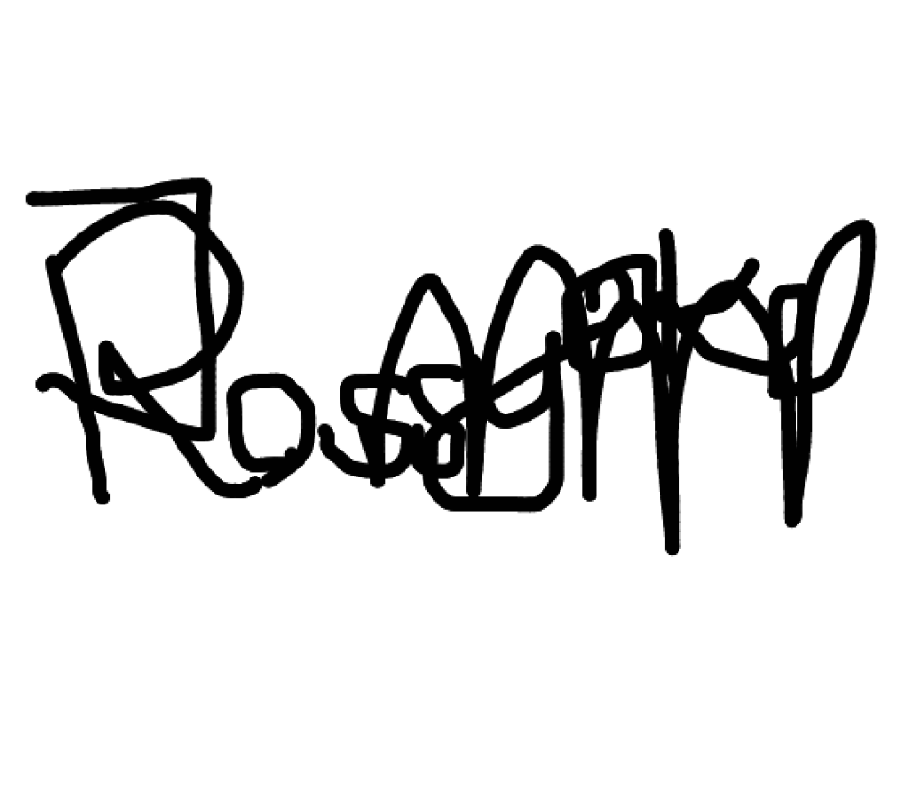
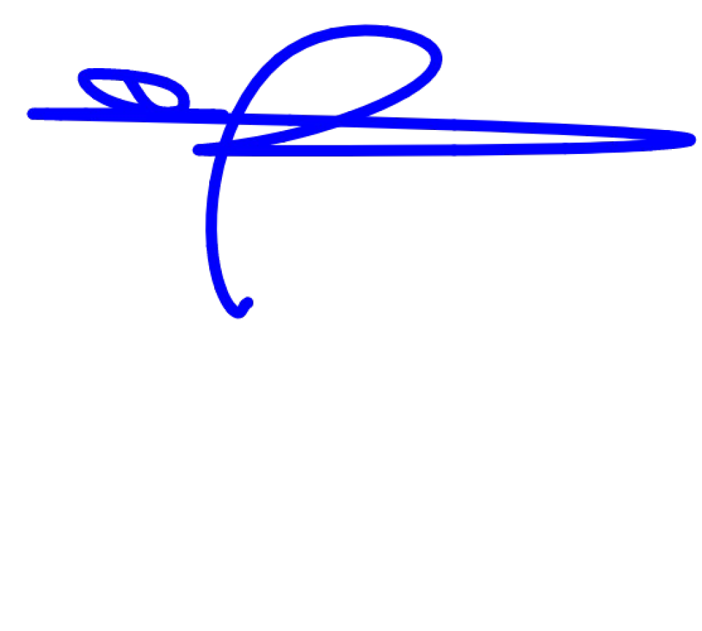
Authorized Signatory Authorized Signatory MEMORANDUM OF ACCEPTANCE

I confirm that having read and understood without any ambiguity, I accept and agree to be bound by the terms and conditions of this Offer Letter dated August 24, 2023 as indicated above on behalf of NNAMDI JOSEPH EGERUE (Borrower) and I hereunder append my signature to the effect accordingly.
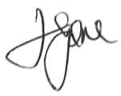

………………………………….
Borrower

IN THE PRESENCE OF:
NAME: EGERUE NGOZI
ADDRESS: NO 3 EHORO CRESCENT ELELENWO PH RIVERS STATE
Phone number: 08163806231

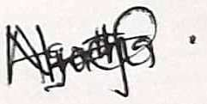

SIGNATURE: ……………………………………………… DATE: 24/08/23………….

